**General Education Updates (Gen Ed 2.1)**

All changes are effective starting in Fall 2026.

**Arts and Humanities**

|  |  |
| --- | --- |
| Current Gen Ed (2.0) | Updated Gen Ed (2.1) |
| 1 Art (3 credits) | 1 Art (3 credits) |
| 1 Humanities (3 credits) | 1 Humanities (3 credits) |
| 1 Art or Humanities (3 credits) |  |

**Diversity is now Breadth of Perspectives**

* Courses that were previously approved for Domestic Diversity will automatically move to the US Perspectives category.
* Courses that were previously approved for Global Diversity will automatically move to the Global Perspectives category.
* A new Civic Literacy category has been created to meet the Senate Bill 1 requirement.

**Civic Literacy**

*Per* [*Senate Bill 1 Sec. 3345.382 (C*](chrome-extension://efaidnbmnnnibpcajpcglclefindmkaj/https:/search-prod.lis.state.oh.us/api/v2/general_assembly_136/legislation/sb1/05_EN/pdf/)*):* Beginning with students who graduate from a state institution of higher education in the spring semester, or equivalent quarter, of the 2029-2030 academic year, no state institution of higher education shall grant a bachelor's degree to any student unless the student completes a course described in division (B) of this section.

Courses under review to meet this requirement

* HIST 250 U.S. History to 1877* – also meets Social Science requirement
* POLIT 100 Government & Politics in the United States* – also meets Social Science requirement
* PHIL is developing a 200 level Philosophical Foundations of American Civic Literacy course that will also meet the Humanities requirements.
* *Other courses may apply if they meet the requirements spelled out in Sec. 3345.382. (B) of Ohio Senate Bill 1.*

Civic Literacy Exemptions

(1) A course offered under the college credit plus program that satisfies the content requirements and is approved by the chancellor.

(2) An AP course and examination that satisfy the content requirements and are approved by the chancellor, and the student receives a score of three or higher on that examination.

**Comparison of current and updated Gen Ed with changes noted in gold**

|  |  |  |
| --- | --- | --- |
|  | Current Gen Ed 2.0 | Updated Gen Ed 2.1 |
| Academic Foundations | 2 Writing courses (6 credits)  ENGL:110 or 111  and  ENGL:112 or 222* | 2 Writing courses (6 credits)  ENGL:110 or 111  and  ENGL:112 or 222* |
| 1 Speaking (3 credits) | 1 Speaking (3 credits) |
| 1 Math, Stats and Logic (3 credits) | 1 Math, Stats and Logic (3 credits) |
| Breadth of Knowledge | 1 Art (3 credits)  1 Humanities (3 credits)  1 Art or Humanities (3 credits) | 1 Art (3 credits)  1 Humanities (3 credits) |
| 2 Natural Science + Lab (7 credits) | 2 Natural Science + Lab (7 credits) |
| 2 Social Science (6 credits) | 2 Social Science (6 credits) |
| Breadth of Perspectives | 1 Domestic Diversity (0 – 3 credits)** | 1 U. S. Perspectives (0 – 3 credits)** |
| 1 Global Diversity (0 – 3 credits)** | 1 Global Perspectives (0 – 3 credits)** |
|  | 1 Civic Literacy (0 – 3 credits)** |
| Integrated and Applied Learning | 1 Approved Capstone (1 – 3 credits) or  Complex Issues Facing Society (3 credits) | 1 Approved Capstone (1 – 3 credits) or  Complex Issues Facing Society (3 credits) |
| Electives |  | Any courses listed above to reach total of 36 |
| Total credits | 36 – 43 credits | 36 – 40 credits |
|  | Applies to current students. | Applies to:   * New UG admission and readmission students starting Fall 2026. * Current students if they are graduating after Summer 2025 and it is advantageous. |

*\*Students who are placed in the second writing course and successfully complete it satisfy the Writing requirement.*

*\*\*May also be an Art, Humanities or Social Science course which would result in zero additional credits.*

*\*\*\*Any course in General Education may also meet program requirements.*

**Visual representation of the updated General Education model**

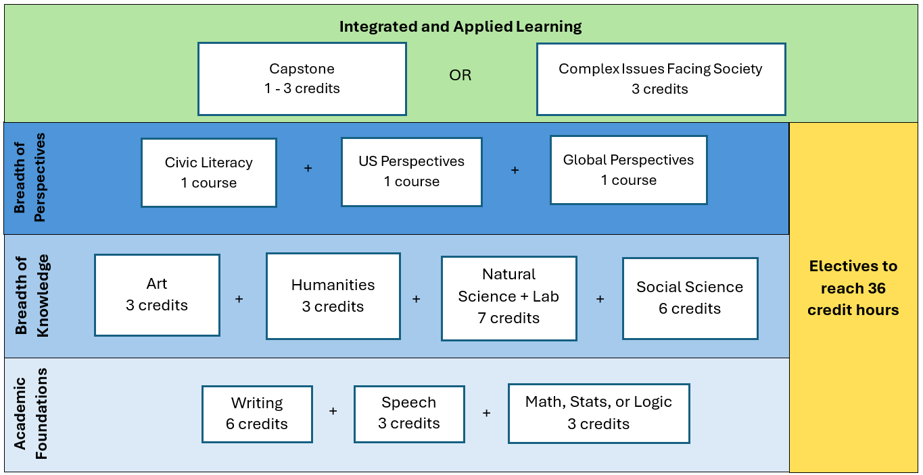

**Curriculum Changes**

1. If Gen Ed requirements are listed generically in your Program Requirements or Plan of Study, then you **do not need a curriculum** proposal but may start advising students with the new requirements starting in fall 2026.

Example: 

1. If Gen Ed requirements are listed more specifically in your Program Requirements or Plan of Study, then you **will need a curriculum proposal** to update them (rename Domestic and Global Diversity and add Civic Literacy) based on the new requirements starting in fall 2026.

Examples:

Spring Semester Header

Social Science Requirement (Domestic Diversity)

Humanities Requirement (Global Diversity)

OR

